Digital meets Analog
It is time to try generating analog output signals, signals that can take a range of different voltages in contrast to the 2-valued signals of the digital world. In this lab we will look building our own dedicated hardware to understand the process.
First you will build a simple hand operated model of a DAC to see what goes on inside and then you will build the real thing and operate it with your computer.
Task 1: Digital to Analog Conversion
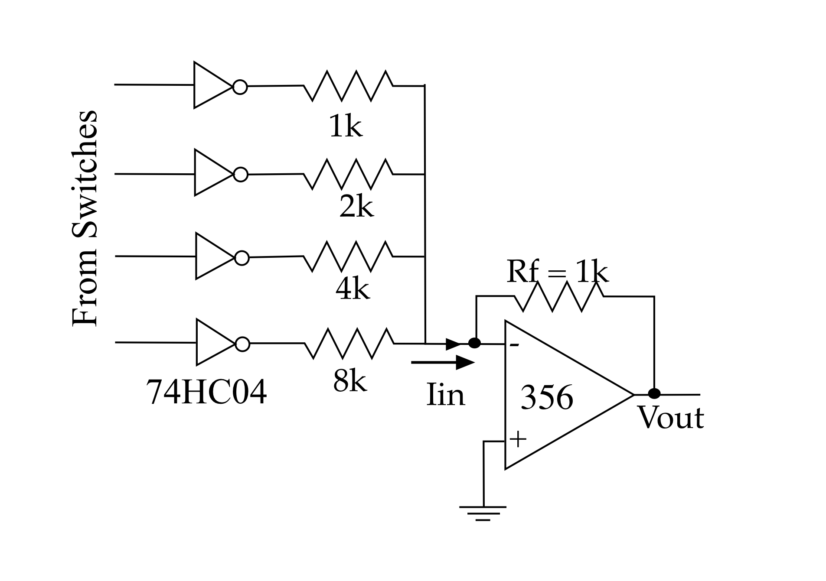
As you have seen in Chapter 27, if we take a trans-resistance amplifier and we give it four inputs that are appropriately ‘weighted’ (that is, the gains for the different inputs are adjusted in just the right way) then we can build a primitive digital-to-analog converter.
Build the circuit on the right on your Designer. Note that you will have to construct some of the resistors out of series combinations of standard value resistors!

a) Explain why the resistors are chosen the way they are.
The resistors are chosen this way so that the “weight” of each line is double that of the line below it.

Given that the outputs from the inverters of the 7404 will be either 0V or 5V, answer the following
b) For each of the 16 different ways of arranging the switches what do you predict the output voltage will be?
Input | Vout Prediction | Input | Vout Prediction
0000 | 0 | 1000 | -5
0001 | -0.625 | 1001 | -5.625
0010 | -1.25 | 1010 | -6.25
0011 | -1.875 | 1011 | -6.875
0100 | -2.5 | 1100 | -7.5
0101 | -3.125 | 1101 | -8.125
0110 | -3.75 | 1110 | -8.75
0111 | -4.375 | 1111 | -9.375

c) Explain your reasoning in numeric detail.
The output voltage of a 4-input DAC with input binary number n is -n/(2^(4-1)).

d) Now, for each of the 16 different inputs, measure the output voltage.
Input | Vout Measured | Input | Vout Measured
0000 | -0.01 | 1000 | -4.8
0001 | -0.63 | 1001 | -5.42
0010 | -1.24 | 1010 | -6.03
0011 | -1.86 | 1011 | -6.65
0100 | -2.45 | 1100 | -7.23
0101 | -3.07 | 1101 | -7.84
0110 | -3.68 | 1110 | -8.44
0111 | -4.3 | 1111 | -9.06

d) What is the largest percentage difference between the predicted and measured output voltage?
On input 1000, the predicted output voltage and the measured output voltage differ by 4%. This is the largest percentage difference out of any of the inputs.

e) Is this difference consistent with the resistor tolerance? Explain your answer in numeric detail.
This is consistent with the resistor tolerance, because the resistors have 5% tolerance.

Task 2: The R-2R DAC
]As discussed in chapter 25, the kind of R, 2R, 4R, 8R, etc., system used in above becomes impractical as the number of bits increases. Instead we turn to the R-2R ladder described in the chapter.
The 8-bit DAC0808
The DAC0808 is an 8-bit current output DAC in a single chip. It contains an R-2R ladder and a set of digitally controlled switches. Each switch is made of four transistors coupled in such a way that when a digital 1 is placed on the control input current can flow from the analog input to the output and when a 0 is placed on the control input that same current flows to ground and does not contribute to the output. The current output from the resistor network appears on pin 4 of the IC and must be connected to a trans-resistance amplifier to give a voltage output.
I have provided you with a complete DAC circuit on a little board. Here is the circuit for the board.
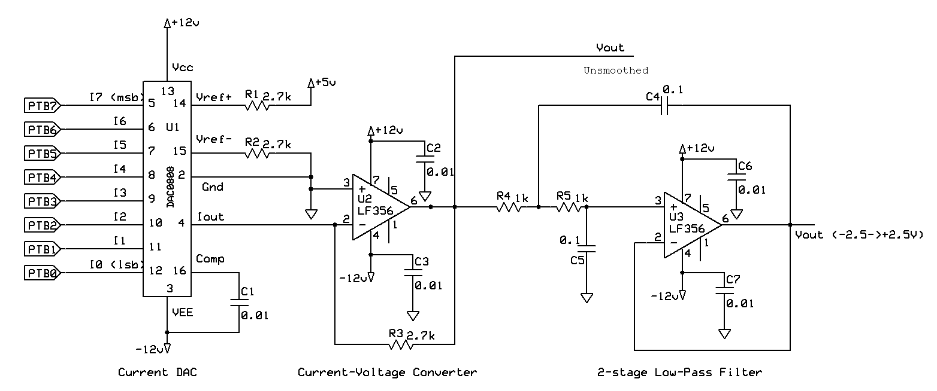
Wire up your board to your Feather. You will need to connect +15V, -15V, +5, and Ground to the board and will also need to wire the 8 input pins to 8 digital outputs on your Feather.
You will take your output from the Unsmoothed output, which is the one that has a blue wire connected to the pin on the board.
Now you need to write a program to control the switches. Because you need to send 8-bit numbers to the 8 output wires you will want to use the techniques from the LED display lab to send an 8-bit number to a sequence (array or tuple) of pins.
Create a program to send all the binary numbers from 0-255 to the port in order at a rate of about 100,000 steps per second.
HINT Look up or remember time.monotonic_ns()
a) Paste your properly commented, working, program below.
# Author: Ben Kallus.
# Counts from 0 to 255 on 8 digital outputs.
from board import *
from digitalio import *
from time import *
P=list(map(DigitalInOut,[SDA,SCL,D5,D6,D9,D10,D11,D12]))
for p in P:p.direction=Direction.OUTPUT
while 1:
for n in range(256):
s=monotonic_ns()
for i in range(8):P[i].value=n&2**i
while monotonic_ns()-s<2*1e5:1

Connect your oscilloscope to the output of the op-amp and look at the signal.
WARNING: Connect your scope signal and ground leads as close to the pins on the board as possible. Long wires will significantly degrade the signals you are looking at.
b) Paste a scope image below.

c) Explain what you see.
The Feather is telling the DAC to increase its voltage by 1/255 of its maximum voltage every 200k ms until the DAC reaches its maximum output voltage, at which point the Feather restarts the DAC at 0.

Keep looking at the output with one channel of the scope and connect the other channel to the least significant bit of the data (the bit that changes every time).
Expand the horizontal scale so that you can see the individual least-significant bits and expand the vertical scale of the output signal trace to look at the structure of the output in as much detail as possible.
d) Paste a scope image below.

e) Explain what you see in detail.
Each step in the output of the DAC corresponds to an incrementing of the output of the Feather.

f) Measure the duration of a single step and so compute how many steps there are in the whole ramp. Does this agree with what you expect from the program? (Explain!)
A single step lasts 0.72ms.

g) Measure the height of a single step and compare this with the full size of the ramp (and you may want to use the Acquire|Average feature of your scope to make the signal easier to see—it will reduce the noise). Do your measurements agree with what you expect? (Explain!).

h) Alter your program so that it generates a triangle wave instead of a sawtooth. Briefly explain how you did this.

i) What is the highest frequency that you can run your triangle wave?

j) Without significantly altering the amplitude of the triangle wave, demonstrate a way to run it twice as fast! How did you do this?

LEAVE YOUR CIRCUIT SET UP! YOU WILL NEED IT ON MONDAY!

